**CONTENTS**

**Chapter 1 Introduction**

1.1 Introduction 02

* 1. Objective 03

1.3 Needs of Tourism Of Nashik 04

**Chapter 2 System Analysis and Requirement**

2.1 Methodology Development Model 06

2.2 Tools and Techniques 08

2.3 Specification Requirement 08

2.4 ER Diagram 09

2.5 Use case Diagram 10

2.6 Flowchart of Tourism Of Nashik 11

**Chapter 3 Task and Activities Performed**

3.1 Implementation 12

3.2 Snap Shots 14

3.3 Future scope 29

**Chapter 4 Conclusion & Reference**

4.1 Conclusion 32

4.2 Reference 32

**Chapter 1**

**INTRODUCTION**

Tourism of Nashik is an innovative online platform designed to offer comprehensive information and services to tourists and locals interested in exploring the vibrant city of Nashik. Known for its rich cultural heritage, beautiful landscapes, and renowned vineyards, Nashik is a prime destination for travelers. Our website serves as a one-stop resource, providing detailed insights into the city's attractions, including local cuisine, accommodations, and popular tourist spots.

**Key features of the Tourism of Nashik website include:**

**Informative Content:** Visitors can explore extensive information about Nashik's famous food, hotels, and local areas. This helps them plan their trip effectively and ensures they do not miss out on any significant experiences.

**Tour Booking Services:** For those looking to visit Nashik, we offer a seamless tour booking option. Users can easily book a tour through our website, and we ensure they receive the best tour guide to enhance their experience.

**Expert Tour Guides:** We pride ourselves on providing knowledgeable and professional tour guides. Our guides are well-versed in Nashik's history, culture, and hidden gems, making each tour memorable and enriching.

**Guide Job Applications:** We also provide an opportunity for individuals passionate about Nashik to join our team as tour guides. Aspiring guides can apply for a job through our website, offering their expertise and love for the city to visitors.

Tourism of Nashik aims to create a user-friendly, informative, and engaging platform that not only promotes the city's tourism but also supports the local community by offering job opportunities. Our goal is to enhance the overall experience of every visitor to Nashik, ensuring they leave with unforgettable memories and a deep appreciation for the city's charm.

**OBJECTIVE**

**Provide Comprehensive Information:**

To offer detailed and accurate information about Nashik's attractions, including local cuisine, hotels, and key tourist spots, helping visitors plan their trips effectively.

**Facilitate Easy Tour Bookings:**

To create a seamless and user-friendly tour booking system that allows visitors to easily schedule and book tours with the best available guides.

**Offer Professional Tour Guides:**

To ensure that tourists have access to knowledgeable and professional tour guides who can provide enriching and memorable experiences during their visit to Nashik.

**Promote Local Tourism:**

To boost local tourism by highlighting Nashik's unique cultural, historical, and natural attractions, encouraging more visitors to explore the city.

**Support Local Employment:**

To create job opportunities for locals by allowing them to apply for positions as tour guides, thereby supporting the local economy and community.

**Enhance User Experience:**

To continuously improve the website's functionality and user experience, making it easy for visitors to find information, book tours, and apply for guide positions.

**Foster Community Engagement:**

To build a community of travelers and locals who share their experiences, reviews, and recommendations, creating a vibrant and interactive platform.

**NEED OF Tourism Of Nashik**

The city of Nashik, known for its rich cultural heritage, scenic beauty, and historical significance, has always been a popular destination for tourists. However, the potential of Nashik as a prime tourist destination has not been fully realized. There are several reasons why the "Tourism of Nashik" project is essential:

**Promotion of Local Culture and Heritage:**

Nashik is home to numerous temples, forts, and historical sites. The project aims to highlight these attractions, bringing them to the attention of a wider audience and preserving the local culture and heritage.

**Boost to the Local Economy:**

Increased tourism leads to higher revenue for local businesses, including hotels, restaurants, and shops. This, in turn, creates more job opportunities for the local population, enhancing the overall economic growth of the region.

**Comprehensive Tourist Information:**

Visitors often struggle to find accurate and reliable information about destinations, accommodations, and local attractions. The "Tourism of Nashik" website provides a centralized platform with detailed information about food, hotels, and local areas, making it easier for tourists to plan their visits.

**Professional Tour Guide Services:**

The project offers a booking system for professional tour guides, ensuring that tourists have knowledgeable and reliable guides to enhance their experience. This service not only benefits tourists but also provides employment opportunities for local guides.

**Simplified Tour Planning:**

By providing a one-stop solution for booking tours, accommodations, and other services, the website simplifies the process of planning a trip to Nashik. This convenience can attract more tourists to the city, contributing to its popularity as a travel destination.

**Enhanced Visitor Experience:**

With features such as user reviews, ratings, and detailed descriptions, tourists can make informed decisions about their travel plans. This enhances their overall experience and satisfaction, encouraging repeat visits and positive word-of-mouth recommendations.

**Opportunity for Locals to Join the Tourism Industry:**

The website offers a platform for locals to apply for jobs as tour guides. This initiative not only provides employment but also ensures that the guides are familiar with the local culture and history, offering tourists an authentic experience.

**Promotion of Sustainable Tourism:**

By managing tourist information and promoting responsible travel practices, the project aims to encourage sustainable tourism in Nashik. This helps in preserving the natural and cultural resources of the area for future generations.

The "Tourism of Nashik" project addresses these needs by providing a comprehensive, user-friendly platform that benefits tourists and the local community alike. It is a vital step towards establishing Nashik as a premier tourist destination, fostering economic growth, and preserving the cultural heritage of the region.

**Chapter 2**

**SYSTEM ANALYSIS AND REQUIREMENT**

**Methodology Development Model**

A Methodology Development Model outlines the structured approach used to develop a project, ensuring all aspects are systematically addressed. For the "Tourism of Nashik" website project, the model includes the following phases:

1. **Requirement Analysis:**

* **Objective:** Understand the needs of users and stakeholders.
* **Activities:** Gather requirements through surveys, interviews, and market analysis; define essential features such as tour booking, guide application, and information pages for food, hotels, and local areas; set clear project goals and objectives.
* **Outcome:** Detailed requirement specification document.

1. **Design:**

* **Objective:** Create the architecture and design of the website.
* **Activities:** Design the system architecture, user interface, and database schema using tools like Figma for UI/UX design; create wireframes, mockups, and database schemas to ensure a cohesive design.
* **Outcome:** Comprehensive design documents, mockups, and database schemas.

1. **Development:**

* **Objective:** Implement the design into a functional website.
* **Activities:** Write code for the frontend using HTML, CSS, and JavaScript; develop the backend using PHP and manage the database with phpMyAdmin; integrate all components to ensure smooth functionality; use Git and GitHub for version control and collaboration.
* **Outcome:** Working prototypes and codebases.

1. **Testing:**

* **Objective:** Ensure the website is bug-free and meets all requirements.
* **Activities:** Perform unit testing, integration testing, and user acceptance testing; identify and fix bugs; ensure compatibility across different devices and browsers.
* **Outcome:** Test reports and bug fixes, ensuring a reliable and user-friendly website.

1. **Deployment:**

* **Objective:** Make the website available for use.
* **Activities:** Deploy the website to a live server using XAMPP; configure servers, set up databases, and ensure the website is accessible online; monitor the initial deployment for any issues.
* **Outcome:** Live, accessible website.

1. **Maintenance and Updates:**

* **Objective:** Keep the website running smoothly and update it as needed.
* **Activities:** Monitor website performance, fix bugs, and add new features based on user feedback; regularly update content to keep information current and relevant; ensure security measures are in place to protect user data.
* **Outcome:** Updated and improved versions of the website, providing a continually enhanced user experience.

**TOOLS AND TECHNIQUES**

1. **Development Tools:**

* **XAMPP:** A free and open-source cross-platform web server solution stack package for PHP development.
* **HTML/CSS/JavaScript:** Frontend technologies for designing and developing the user interface.
* **PHP:** Server-side scripting language designed for web development.
* **Bootstrap:** CSS framework for responsive and mobile-first web development.
* **Git:** Version control system for tracking changes in the source code during development.
* **GitHub:** Web-based platform used for version control and collaborative coding.
* **Figma:** UI/UX design tool for creating wireframes, mockups, and prototypes.

1. **Database Tools:**

* **MySQL:** Database management system for storing user data, employee details, and tour assignments.
* **phpMyAdmin:** Tool for managing MySQL databases, including the storage of user data and tour information.

1. **Integrated Development Environments (IDEs):**

* **Visual Studio Code:** Popular IDE with support for PHP, HTML, CSS, JavaScript, and various extensions for debugging and version control.

1. **Documentation:**

* **Markdown:** Lightweight markup language for creating README files and documentation, ensuring clear and concise project documentation.

**SPECIFICATION REQUIREMENT**

**Processor:** Minimum Intel i3 or equivalent.

**RAM:** Minimum 4GB.

**HDD:** 80GB to 1TB.

**LAN:** Net connection.

**Browser:** Compatible with Internet Explorer, Firefox, Chrome, Microsoft Edge, etc.

**USE CASE DIAGRAM** 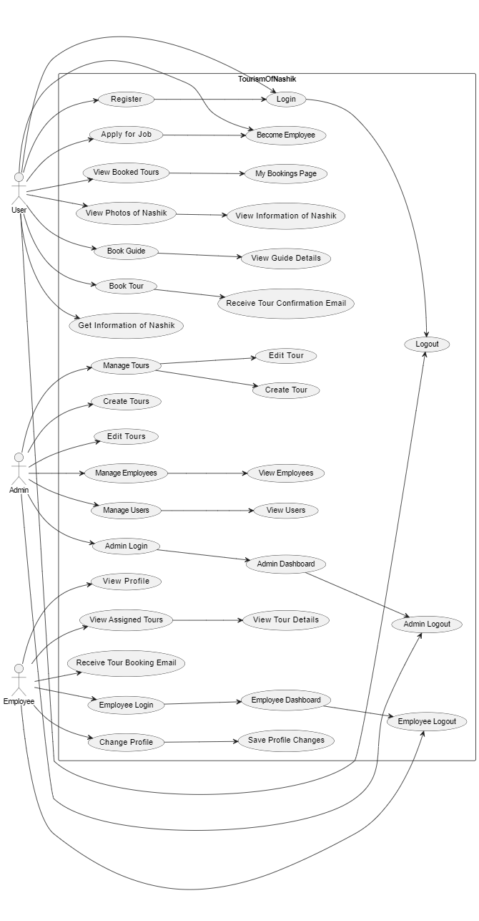

**ER DIAGRAM**

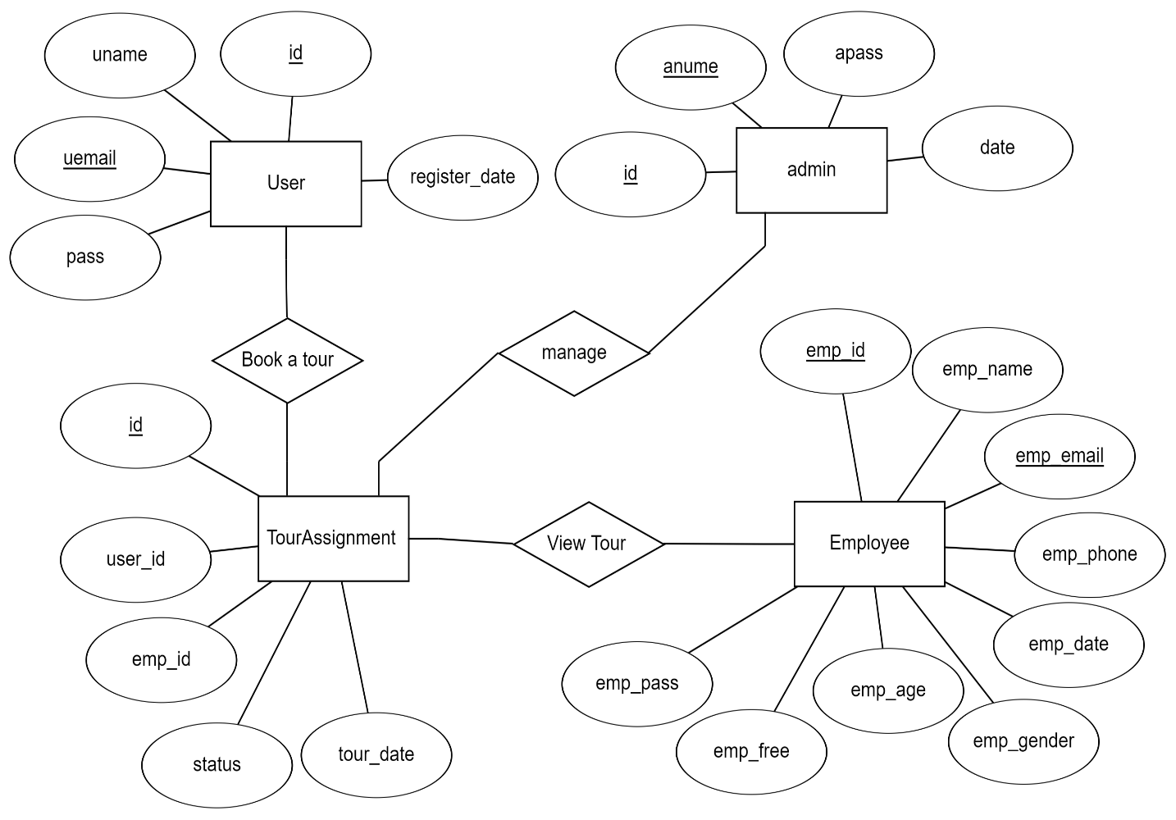

**FLOWCHART**

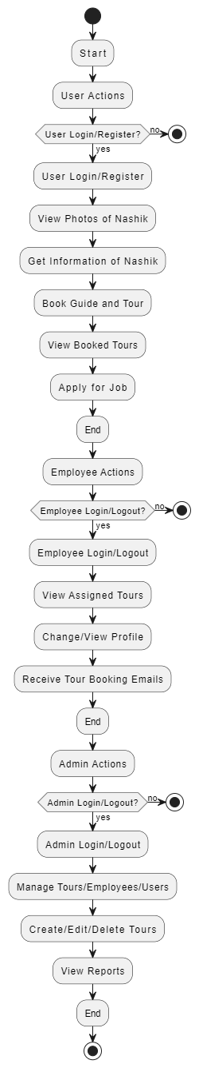

**Chapter 3**

**Task and Activities Performed**

**IMPLEMENTATION**

**1. Frontend Development:**

* **User Interface Design:** Created the user interface using HTML, CSS, and JavaScript. Used Bootstrap for responsive design.
* **Dynamic UI Elements:** Developed dynamic elements such as tour booking forms, user registration/login pages, and information pages about Nashik.
* **Event Handling:** Implemented JavaScript functions to handle user interactions, such as booking tours, applying for jobs, and navigating through the website.

**2. Backend Development:**

* **Setting Up the Server:** Set up a PHP server using XAMPP to handle HTTP requests and serve static files.
* **Real-Time Communication:** Configured email notifications for real-time communication between the client and server. The server handles events like tour booking confirmations and notifications to guides.
* **API Endpoints:** Created RESTful API endpoints for user authentication, tour booking, employee management, and other necessary operations.

**3. Database Integration:**

* **Choosing the Database:** Selected MySQL as the database for storing user data, employee details, tour bookings, and other relevant information.
* **Database Schema:** Designed and implemented a database schema that includes tables for users, employees, tours, and bookings.

**4. Connectivity and Integration:**

* **Connecting Frontend to Backend:** Ensured seamless communication between the frontend and backend using AJAX and PHP.
* **Handling CORS:** Configured the backend to handle CORS (Cross-Origin Resource Sharing) to allow connections from different origins.
* **Testing Communication:** Tested the connection by booking tours and ensuring data is correctly stored and retrieved from the database.

**5. Testing and Debugging:**

* **Unit Testing:** Conducted unit tests for individual components and functions to ensure they work as expected.
* Integration Testing: Tested the interaction between different components, such as frontend and backend, and server and database.
* **User Testing:** Performed user testing to gather feedback and identify usability issues.

**6. Deployment:**

* **Deploying the Application:** Deployed the application to a live environment, ensuring it is accessible to users.
* Monitoring and Maintenance: Set up monitoring tools to track the application's performance and address any issues that arise post-deployment.

**7. Final Touches:**

* **Styling and Optimization:** Enhanced the user interface with additional styling and optimized the performance of the application.
* **Documentation:** Created comprehensive documentation for the codebase, API endpoints, and a user guide for future reference and maintenance.

**SNAPSHOTS**

**Register Page :**

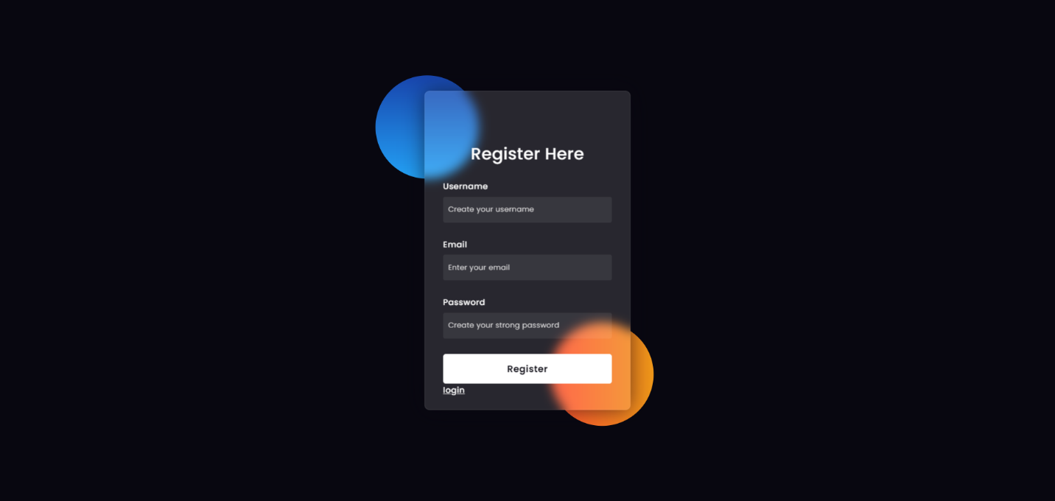

**Log in Page :**

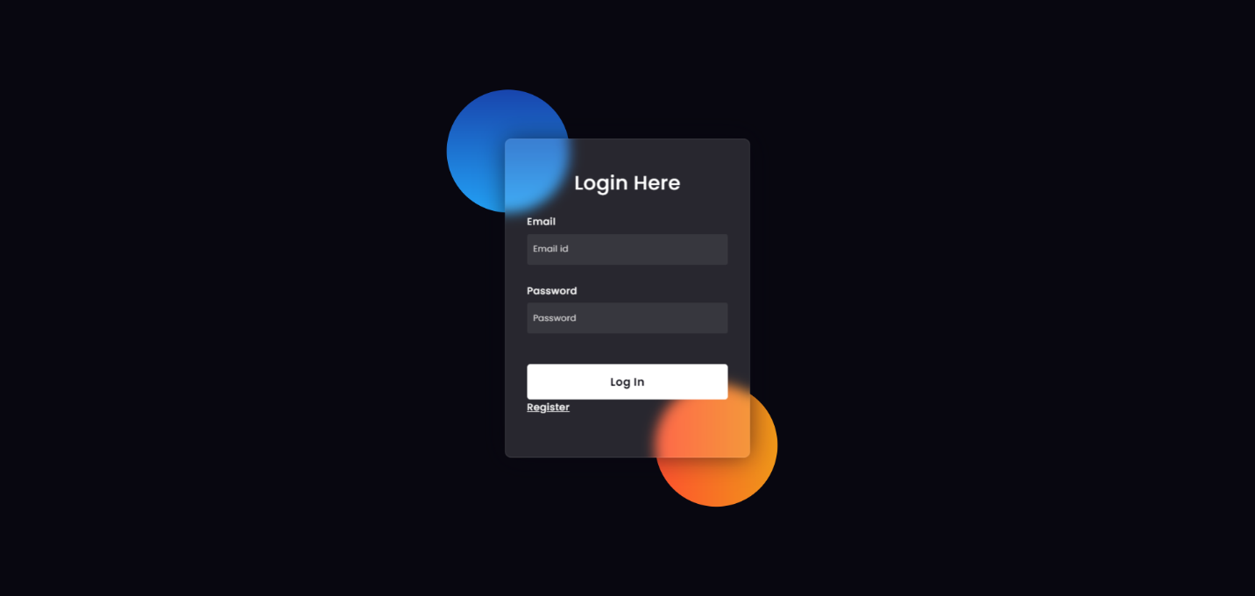

**Home Page :**

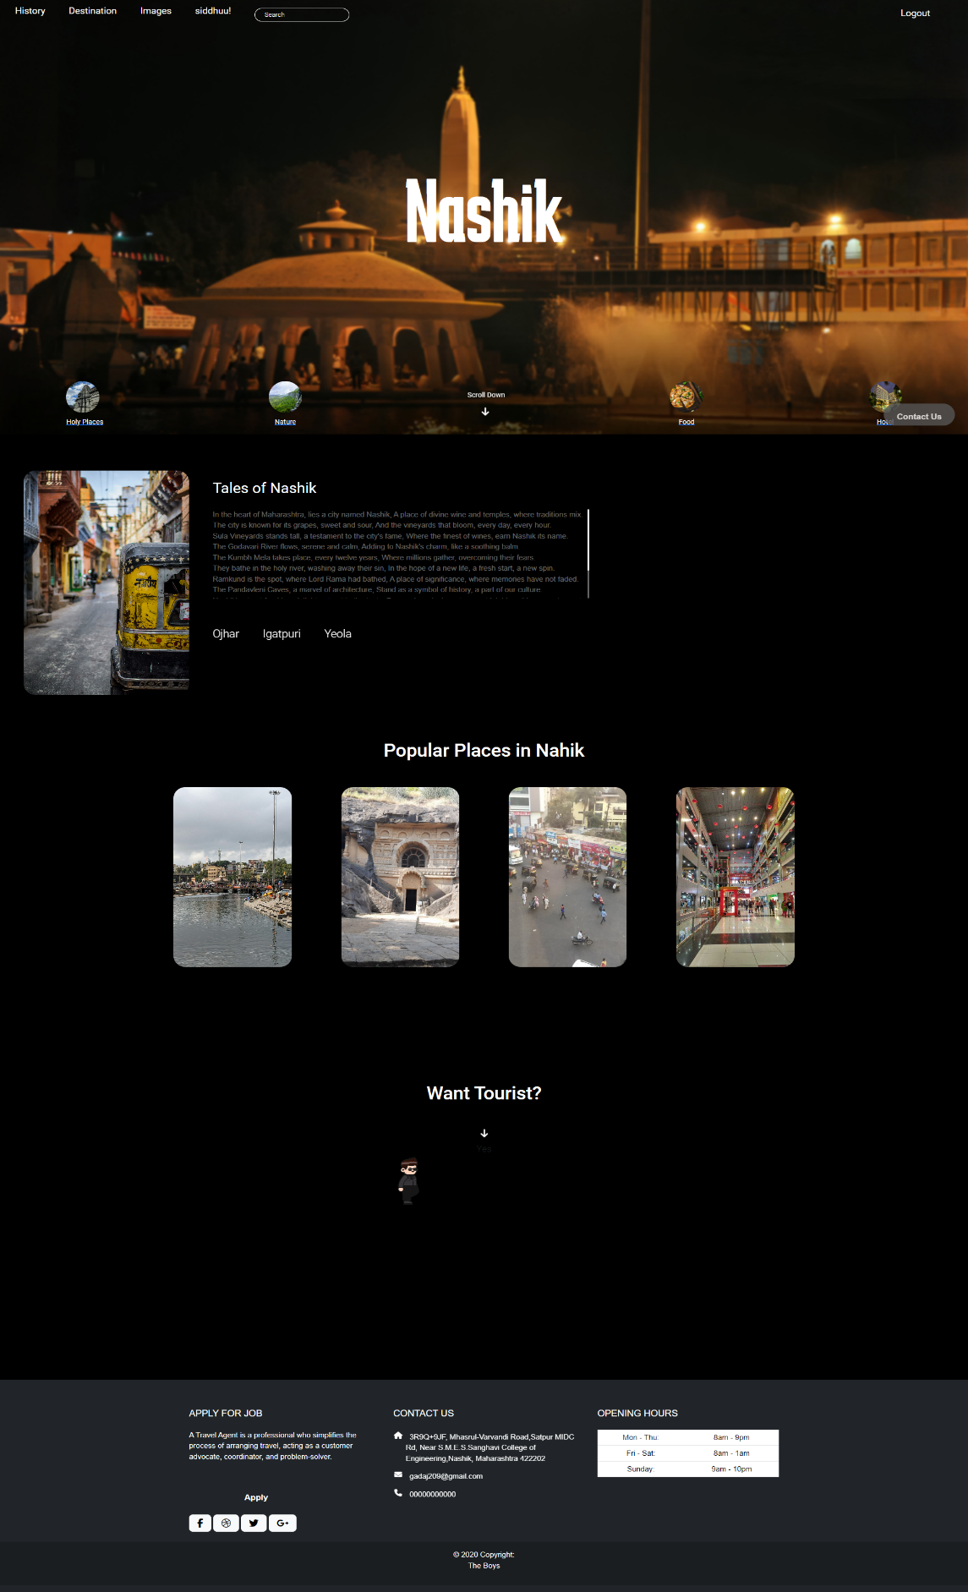

**Histroy Of Nashik Page :**

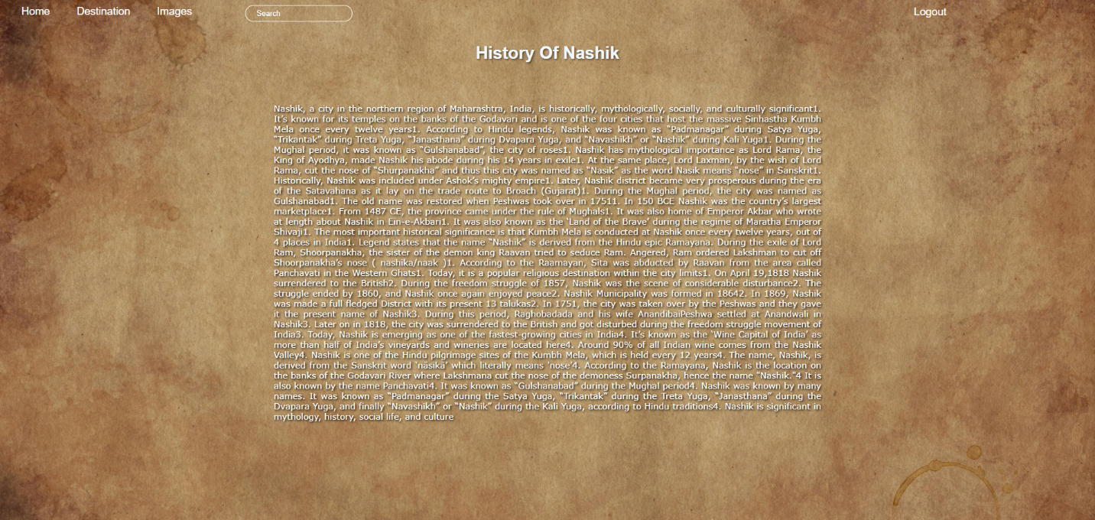

**Google Map Page :**

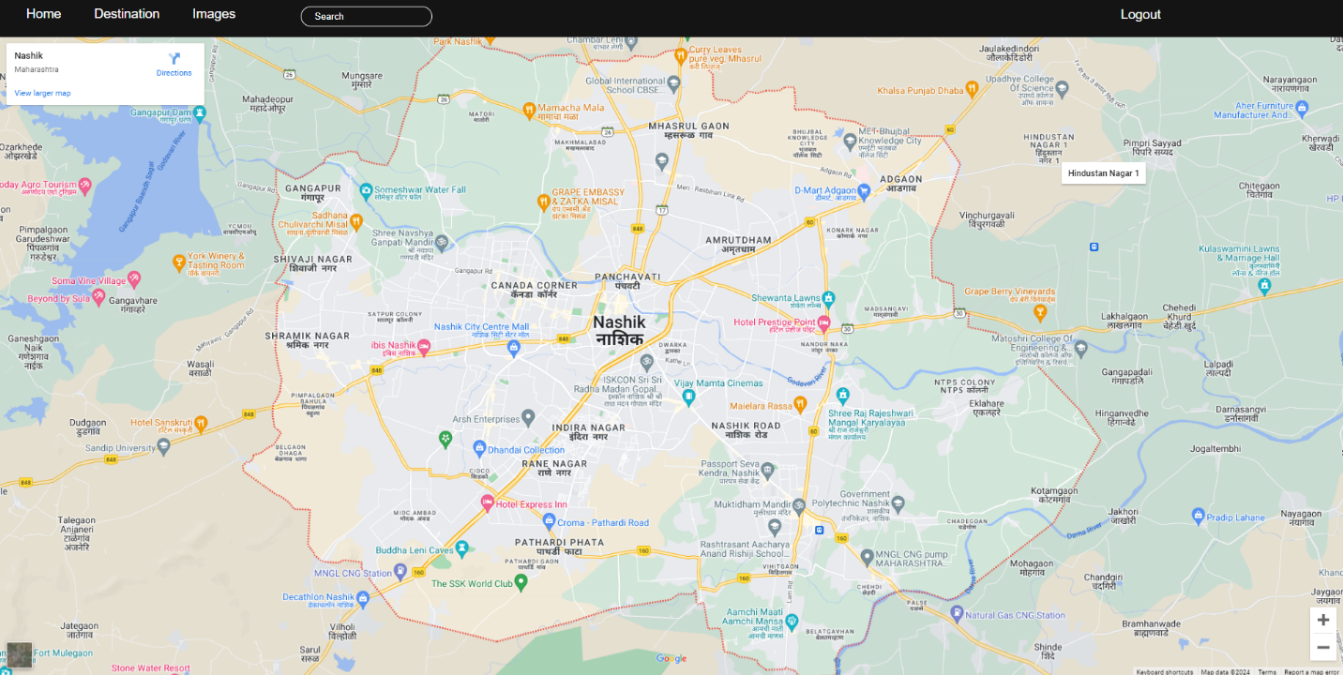

**Images Page :**

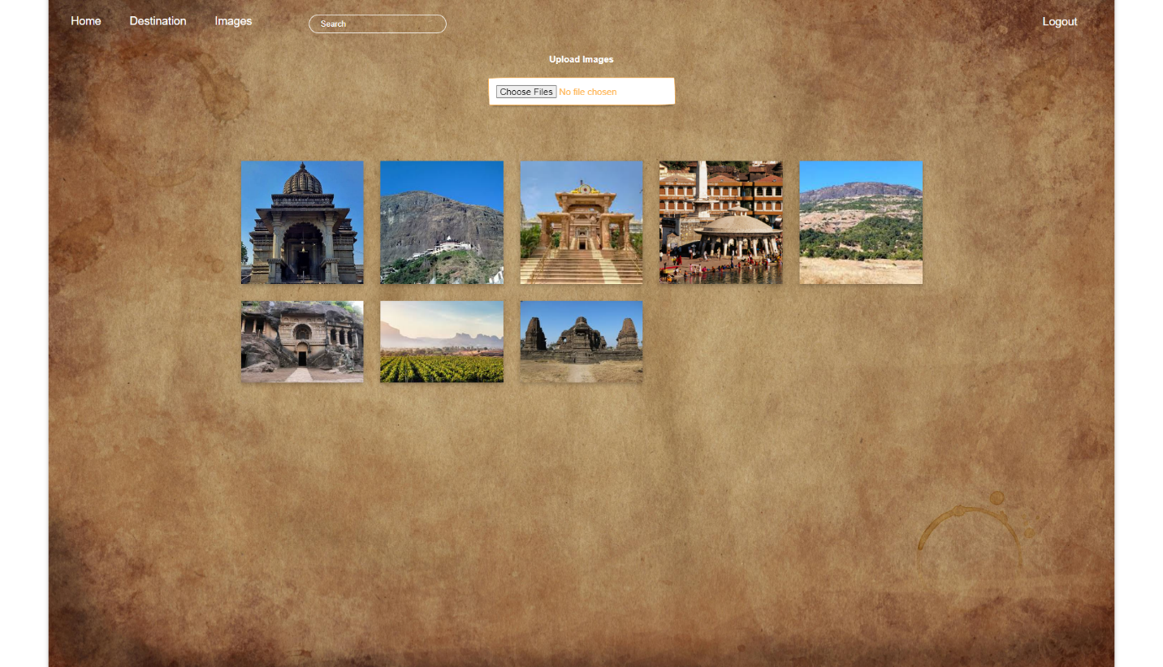

**Holy Page :**

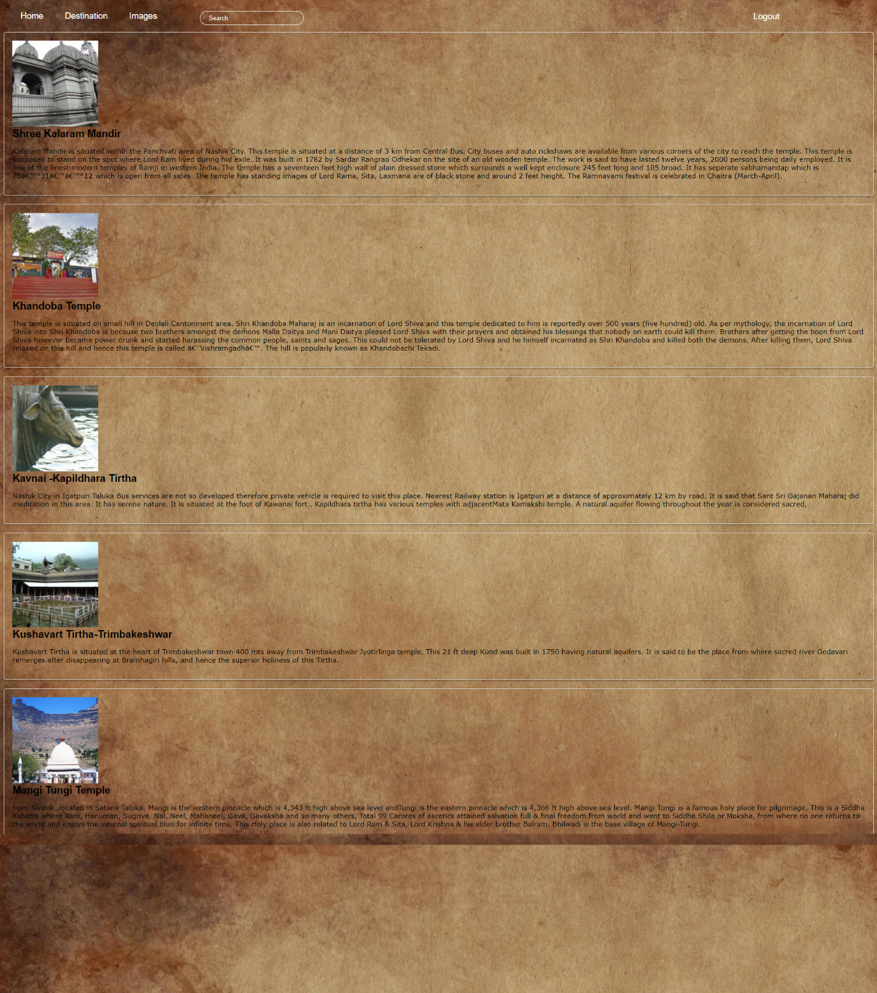

**Nature Page :**

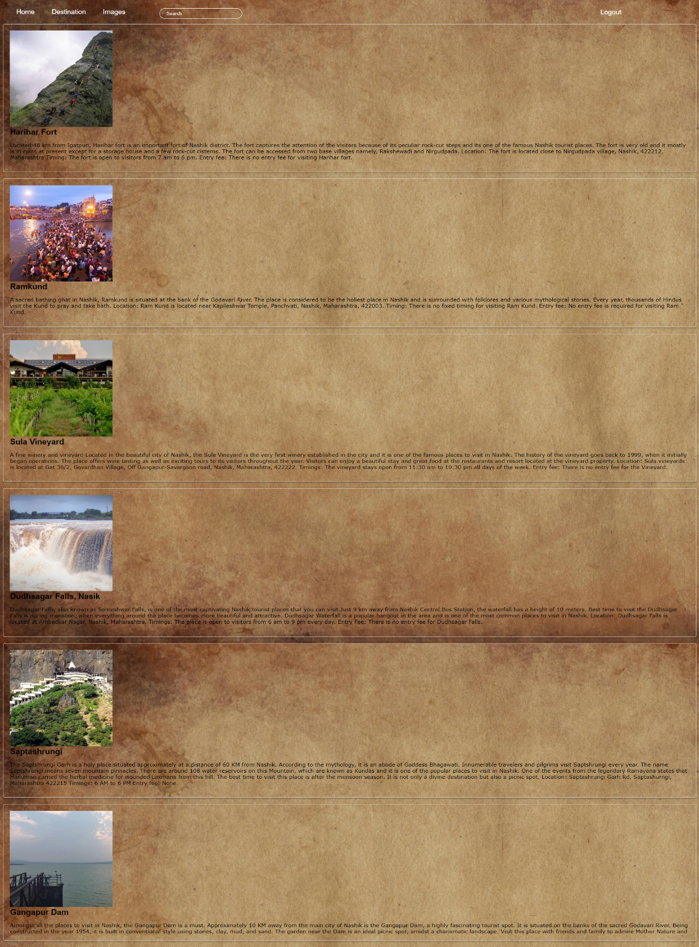

**Apply For Job Page :**

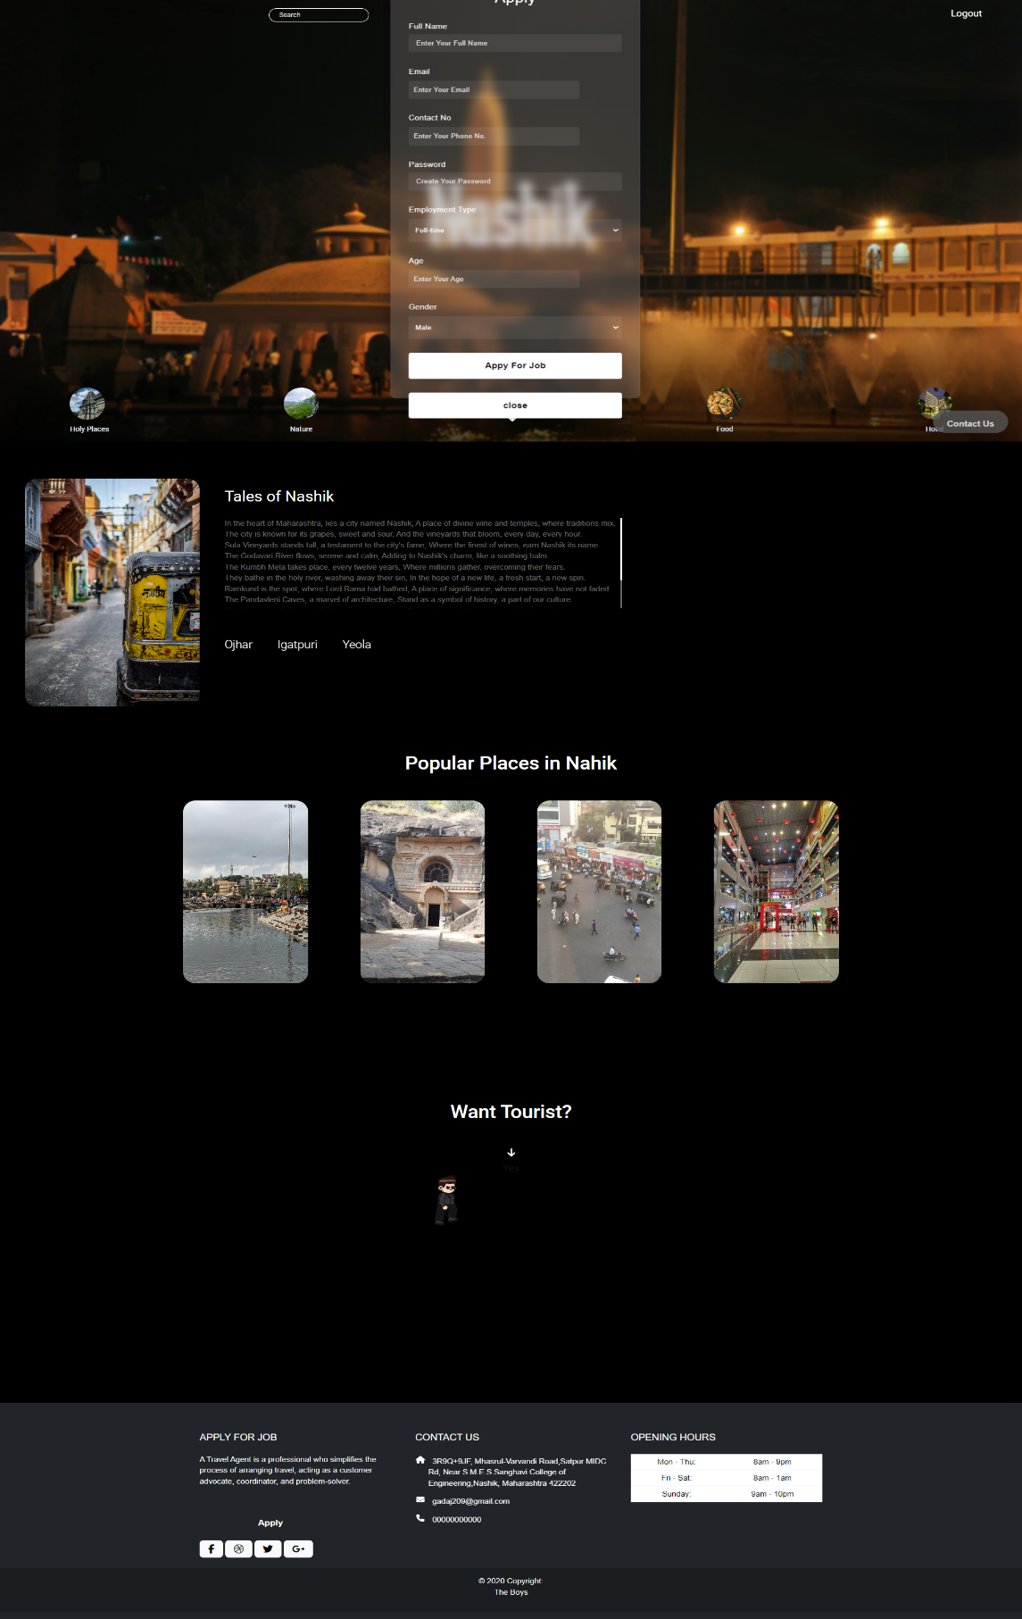

**Booking Page :**

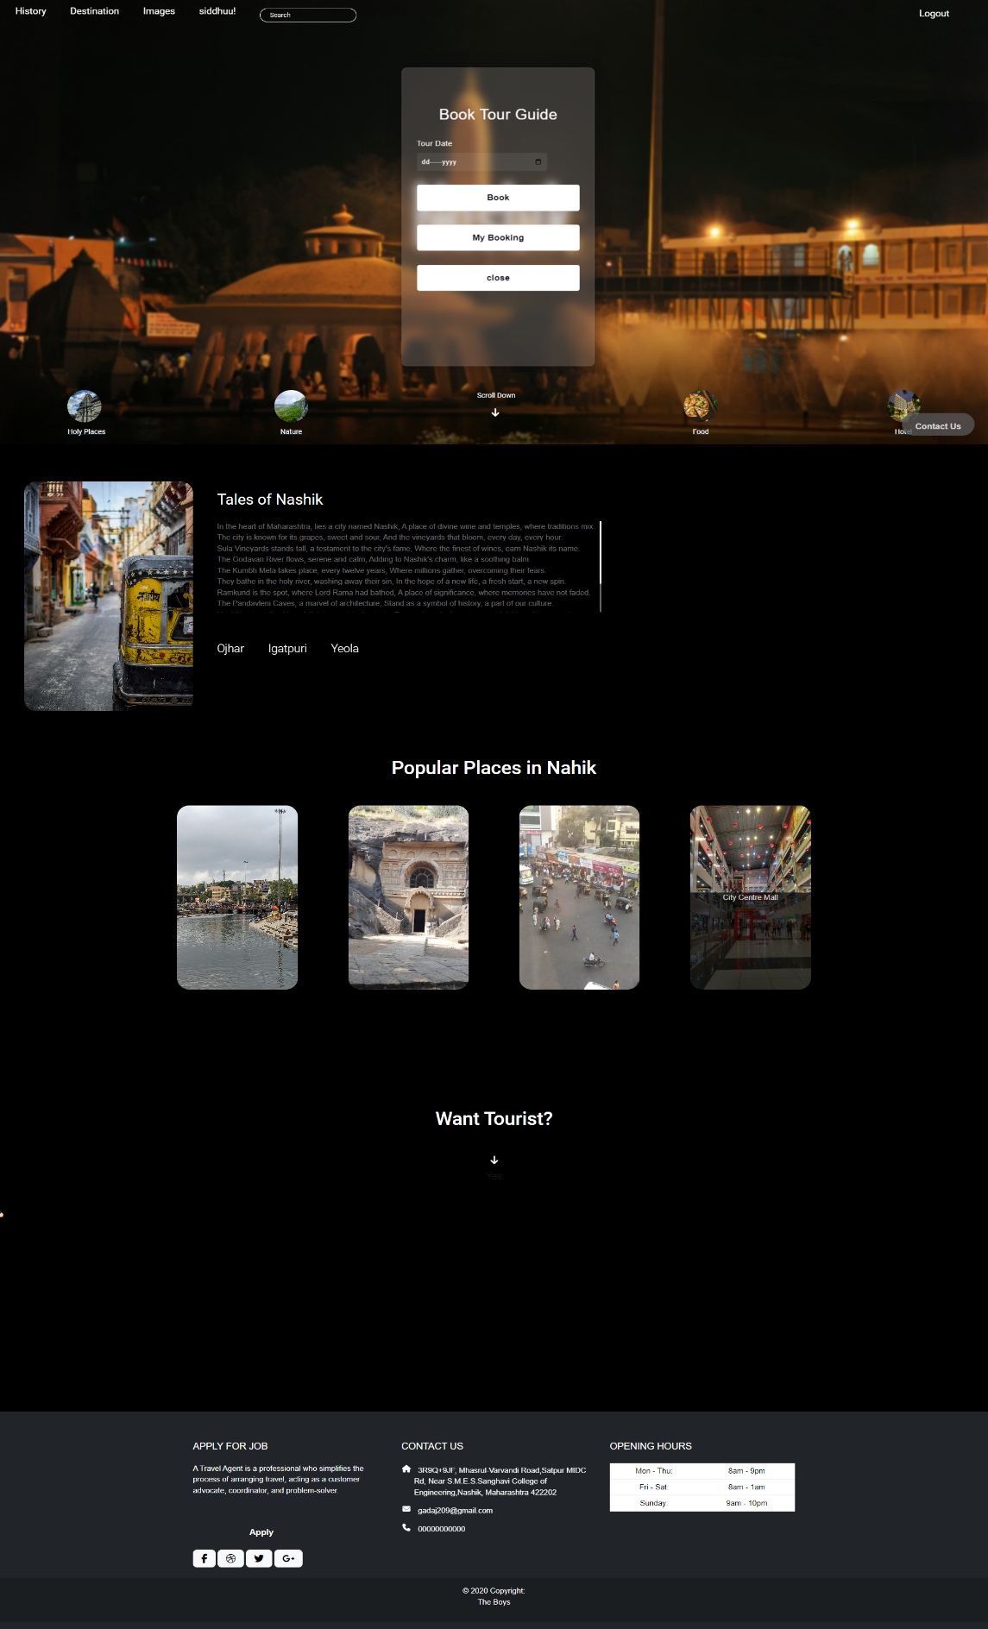

**Veiw Booking Page :**

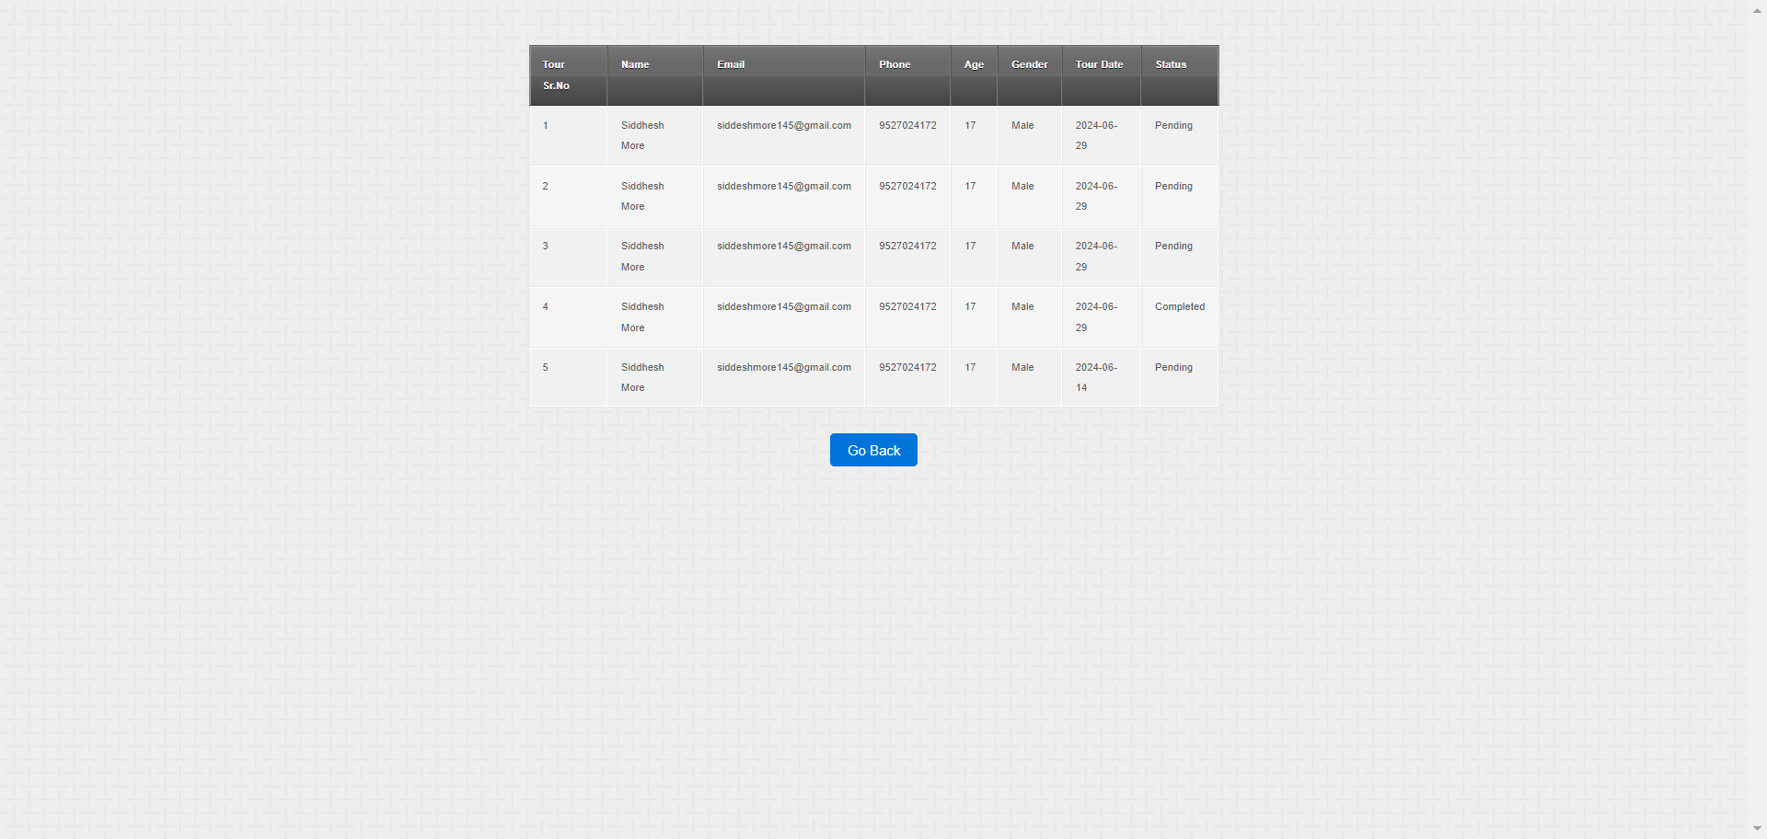

**Employee Login Page :**

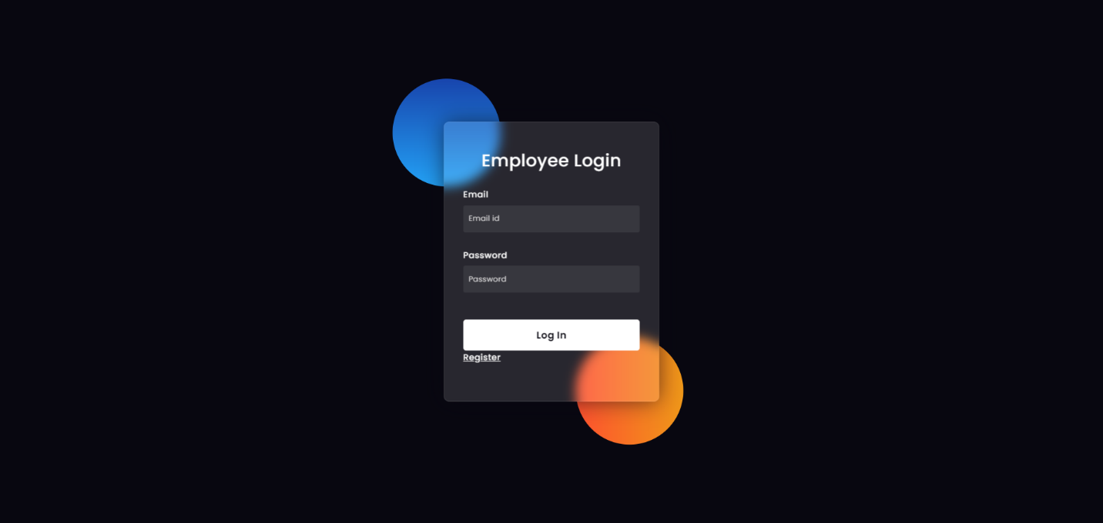

**Employee Page :**

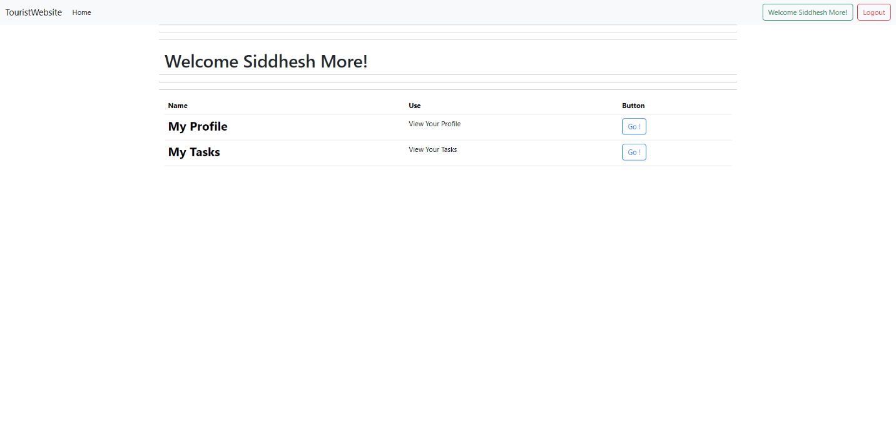

**Employee Profile Page :**

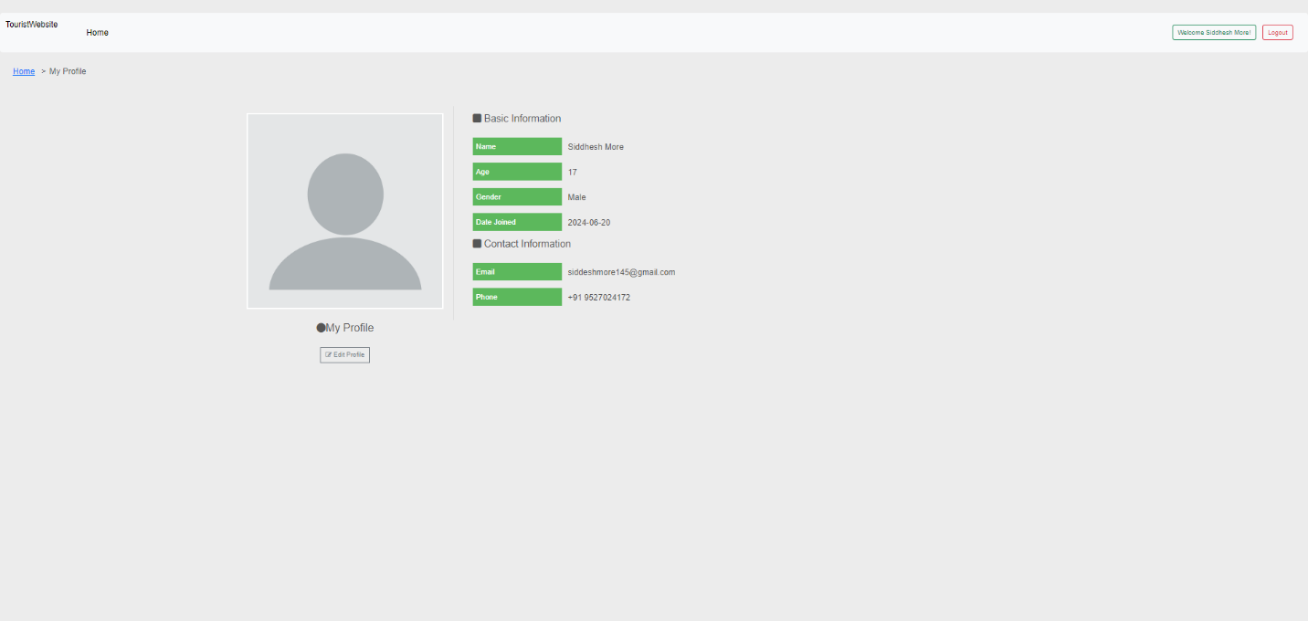

**Employee Edit Page :**

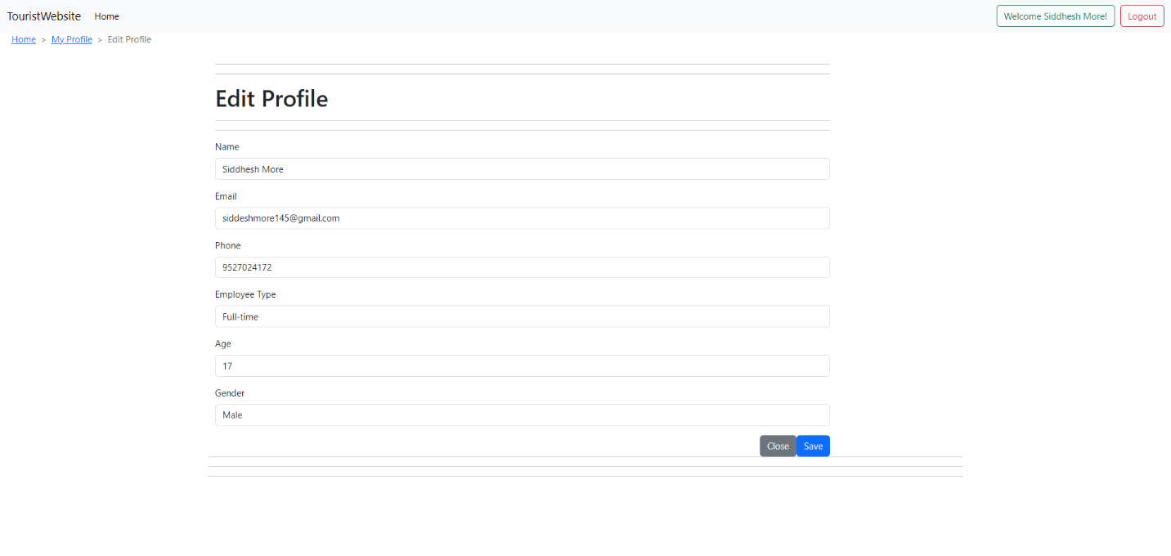

**Employee Tasks Page :**

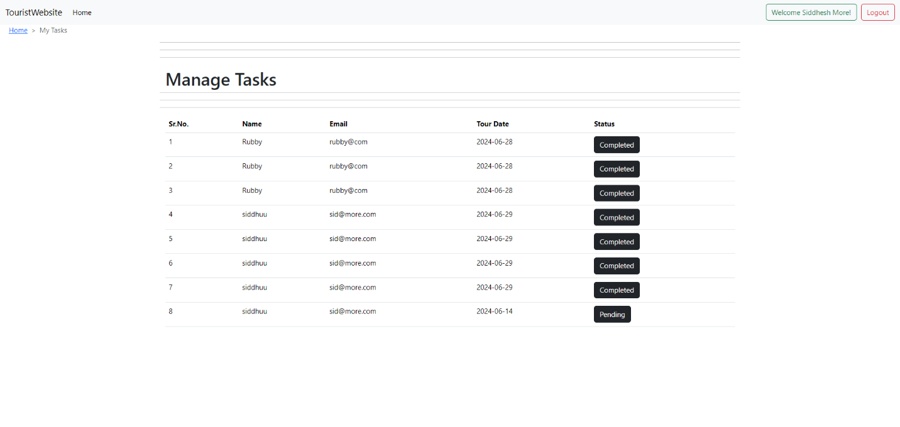

**Admin Login Page :**

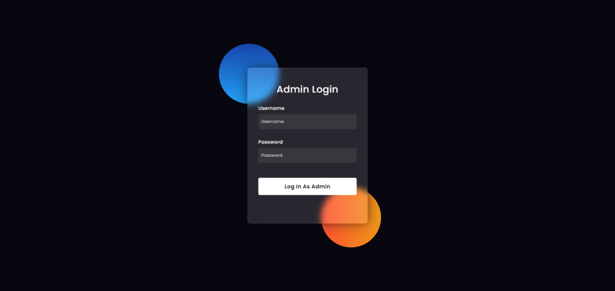

**Admin Page :**

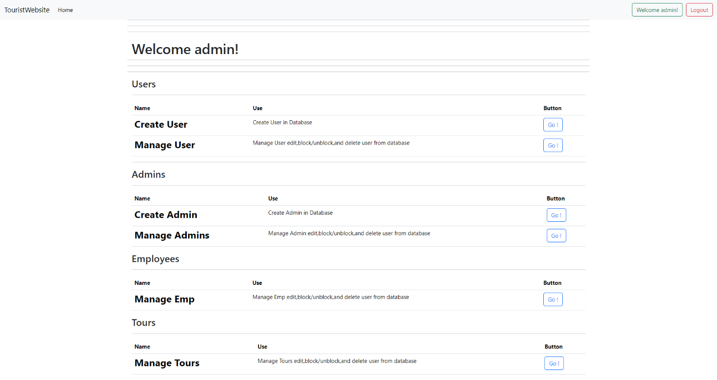

**Create User Page :**

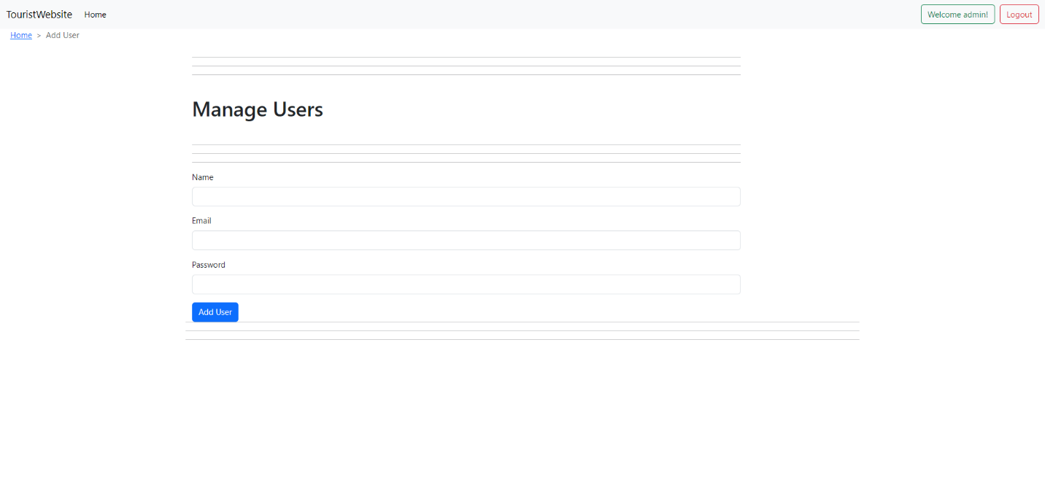

**Manage User Page :**

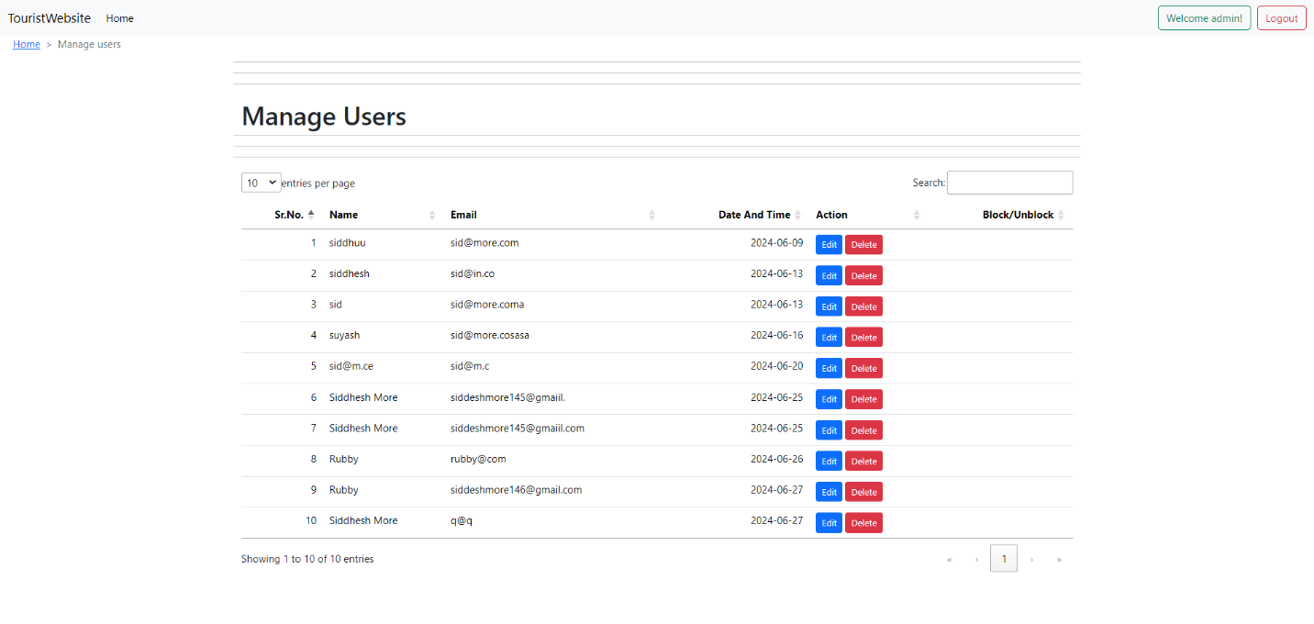

**Create Admin Page :**

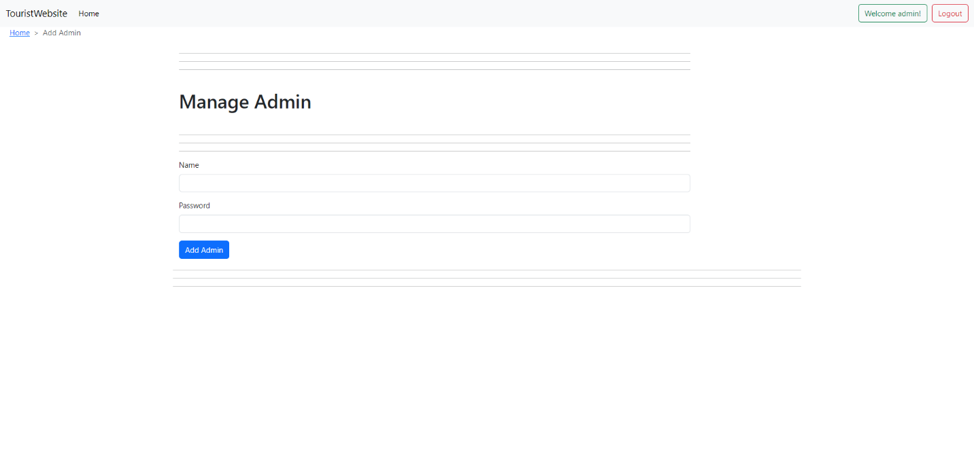

**Manage Admin Page :**

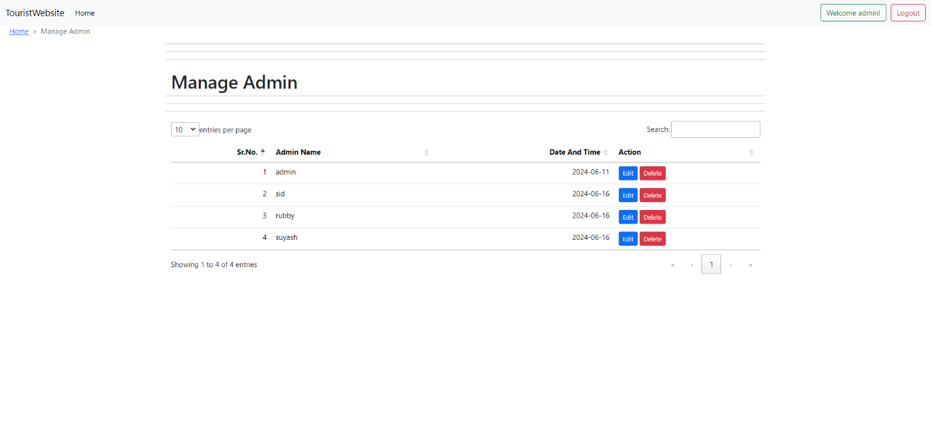

**Manage Employee Page :**

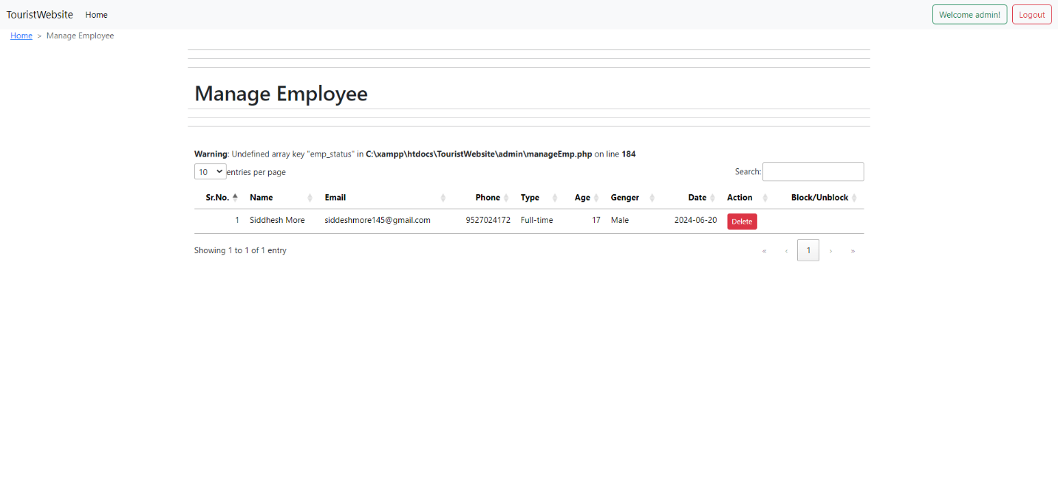

**FUTURE SCOPE**

### **1. Advanced Features:**

* **Detailed Tour Information**: Enhance the website with more detailed and interactive tour information, including virtual tours and 360-degree images.
* **Advanced Booking Options**: Allow users to book additional services such as transportation and meal plans along with tours.
* **Personalized Recommendations**: Use AI to recommend tours and activities based on user preferences and past bookings.

### **2. Enhanced Security:**

* **End-to-End Encryption**: Implement end-to-end encryption to ensure secure communication between users and guides.
* **Two-Factor Authentication**: Add two-factor authentication (2FA) for enhanced user and employee security.
* **Advanced User Permissions**: Develop a robust permission system to manage user roles and access levels, ensuring that only authorized personnel can access sensitive information.

### **3. Scalability:**

* **Load Balancing**: Implement load balancing to handle increased traffic, especially during peak tourist seasons, ensuring smooth performance.
* **Microservices Architecture**: Transition to a microservices architecture for better scalability and maintainability.
* **Horizontal Scaling**: Plan for horizontal scaling to add more servers and manage a growing user base efficiently.

### **4. Integration with Other Services:**

* **Social Media Integration**: Allow users to log in using their social media accounts and share their tour experiences on social platforms.
* **Third-Party APIs**: Integrate with third-party APIs to provide additional functionalities such as weather forecasts, currency converters, and local event information.

### **5. AI and Machine Learning:**

* **AI-Powered Chatbots**: Develop AI-powered chatbots to assist users with booking tours, answering queries, and providing personalized recommendations.
* **Natural Language Processing**: Implement NLP techniques to better understand and respond to user inquiries.
* **User Behavior Analysis**: Use machine learning algorithms to analyze user behavior and provide personalized tour suggestions and offers.

### **6. User Experience Enhancements:**

* **Customizable Themes**: Allow users to customize the website interface with different themes and layouts for a more personalized experience.
* **Emojis and Reviews**: Add support for emojis and user reviews to make the platform more engaging and interactive.
* **Offline Access**: Implement offline access to certain features so users can plan their trips even without an internet connection.

### **7. Cross-Platform Compatibility:**

* **Mobile Applications**: Develop native mobile applications for iOS and Android to reach a wider audience and provide a seamless booking experience.
* **Desktop Applications**: Create desktop versions of the website for Windows, macOS, and Linux users.
* **Progressive Web App (PWA)**: Build a PWA to offer a consistent and fast experience across different devices and platforms.

### **8. Analytics and Reporting:**

* **Usage Analytics**: Implement analytics to track user activity, booking trends, and other key metrics to inform business decisions.
* **Admin Dashboards**: Provide comprehensive admin dashboards for monitoring and managing tours, user activity, and employee performance.
* **User Feedback**: Collect user feedback to continuously improve the platform based on user preferences and requirements.

### **9. Globalization and Localization:**

* **Multilingual Support**: Add support for multiple languages to cater to a global audience, making the platform accessible to more users.
* **Localization**: Customize the website interface and content to suit different cultural and regional preferences, enhancing user experience.

### **10. Community and Collaboration Features:**

* **Forums and Discussion Boards**: Introduce forums and discussion boards for users to share their experiences, ask questions, and engage with the community.
* **Collaborative Tools**: Integrate collaborative tools like shared itineraries and group planning features for users traveling in groups or with families.

By pursuing these future enhancements, the "Tourism of Nashik" website can evolve into a comprehensive tourism platform that meets diverse user needs and adapts to emerging technological trends.

**Chapter 3**

**Task and Activities Performed**

### **Conclusion**

The "Tourism of Nashik" project not only meets the immediate requirements of providing comprehensive information and services for tourists but also sets the stage for continuous improvement and innovation. With a clear roadmap for future development, "Tourism of Nashik" is poised to become a comprehensive and versatile platform that caters to a wide range of tourist needs, enhancing the overall experience for users.

### **Reference**

* XAMPP. (n.d.). XAMPP documentation. Retrieved from https://www.apachefriends.org/docs/
* MySQL. (n.d.). MySQL documentation. Retrieved from <https://dev.mysql.com/doc/>
* Bootstrap. (n.d.). Bootstrap documentation. Retrieved from <https://getbootstrap.com/docs/5.0/getting-started/introduction/>
* Git. (n.d.). Git documentation. Retrieved from <https://git-scm.com/doc>
* GitHub. (n.d.). GitHub documentation. Retrieved from <https://docs.github.com/en>
* MDN Web Docs. (n.d.). CORS. Retrieved from <https://developer.mozilla.org/en-US/docs/Web/HTTP/CORS>
* Visual Studio Code. (n.d.). Visual Studio Code documentation. Retrieved from <https://code.visualstudio.com/docs>